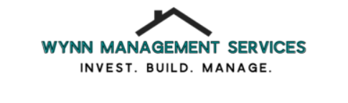

Required documents for application process:

- Rental verification form ( you can find this form on our website under More<Documents)
- 3 FULL MONTHS of paystubs, Offer letter OR letter of employment (this will need to state your income and contact info so that we may verify income with your employer)
- Apply on our website for the desired property (this includes a background & credit check. We do not have a minimum credit score, we look at debt to income ratio using the provided paystubs/offer letter/employment letter.) You will need to approve the credit & background check via email from My Smart Move
- DEPOSIT in the form of check or money order (If you put down a deposit this puts your name at the top of the list, if you are for some reason not approved you will get your deposit back IN FULL)

